
DE MONTFORT UNIVERSITY LEICESTER

AI System for News Bias and Misinformation Analysis with Responsible AI Considerations:

A Thesis Submitted in Partial Fulfillment of the Requirement for the Degree of Master of Science in Artificial Intelligence
Computer, Engineering and Media Faculty
De Montfort University, Leicester

By
Muhammad Rizwan Riaz
Master of Science in Artificial Intelligence
Supervised by
Dr Aboozar Taherkhani
School of Computer Science and Informatics
Computer, Engineering and Media Faculty

Acknowledgement:
First and foremost, I would like to express my gratitude to Almighty God for His mercy, guidance, strength, and countless blessings throughout my academic journey. Without His support, the completion of this research project would not have been possible.

I would also like to sincerely thank my beloved family for their continuous encouragement, patience, emotional support, and understanding throughout my studies and during the completion of this dissertation. Their motivation and sacrifices have always inspired me to continue pursuing my academic and professional goals.

My sincere appreciation goes to my supervisor, Dr Aboozar Taherkhani, for his valuable guidance, constructive feedback, and continuous support throughout this research project. His academic advice, technical suggestions, and encouragement significantly contributed to the successful completion of this dissertation. I am particularly grateful for the time and effort he dedicated to explaining complex research concepts and providing direction during both the implementation and evaluation stages of the project.

I would also like to acknowledge De Montfort University, Leicester, and the Faculty of Computing, Engineering and Media for providing the academic environment and resources necessary for conducting this research.

Finally, I would like to thank everyone who directly or indirectly supported me throughout this MSc journey and contributed towards the completion of this dissertation.

Abstract:
Artificial Intelligence (AI) and Large Language Models (LLMs) are becoming increasingly common within journalism, automated reporting, and digital media platforms. These technologies can generate large amounts of text quickly and efficiently, creating new opportunities for automated content production. However, their growing use has also raised concerns about misinformation, hallucinated information, linguistic bias, and the reliability of AI-generated news content (Bender et al., 2021; Weidinger et al., 2021). As AI-generated articles can appear credible and convincing, there is an increasing need for methods capable of assessing the quality, trustworthiness, and transparency of automated journalism.
This research explores these challenges through the development of an agentic AI workflow designed to analyse bias and misinformation risks within AI-generated journalism while incorporating Responsible AI principles. The project developed an automated system that collects live news articles from BBC and Guardian RSS feeds, generates news-style articles using a GPT-based language model, and compares the generated content with the original source material. The workflow was implemented using the n8n automation platform together with Python analytical scripts for text preprocessing, sentiment estimation, semantic overlap evaluation, and comparative bias analysis.
The research adopted a comparative experimental approach inspired by the multi-level bias analysis framework proposed by Fang et al. (2024). The workflow incorporated word-level, sentence-level, and document-level analytical techniques to evaluate differences between original and AI-generated articles. Word-level analysis examined the occurrence of predefined emotionally weighted vocabulary, sentence-level analysis estimated sentiment variation and emotional tone, while document-level analysis combined these measures to assess overall linguistic framing. A semantic overlap analysis technique was also used to estimate factual similarity and potential misinformation risk between original and generated content.
Within this study, misinformation risk referred to situations where generated articles showed reduced similarity, narrative variation, or unsupported contextual interpretation when compared with the original source article. Rather than relying on external fact-checking systems, the workflow estimated misinformation risk through computational comparison of original and generated articles. Potential hallucination indicators were also examined through differences in wording, semantic overlap, and contextual framing. Linguistic bias was evaluated through sentiment analysis, vocabulary comparison, and framing assessment techniques implemented within the Python analytical scripts.
The findings revealed measurable differences in sentiment intensity, linguistic framing, and semantic similarity between professionally written journalism and AI-generated outputs. The results suggest that AI-generated articles can introduce subtle changes in narrative structure and interpretation despite producing coherent and realistic news-style content. At the same time, the study recognises that computational analysis provides indicators rather than definitive proof of misinformation or political bias, as factors such as journalistic intention, context, and socio-cultural interpretation remain difficult to assess automatically.
The project also demonstrated the importance of Responsible AI practices within automated journalism systems. Transparency was supported by clearly distinguishing between original and AI-generated content, while explainability was enhanced through visible analytical outputs including bias scores, sentiment measurements, similarity values, and misinformation risk indicators. Overall, this research demonstrates how workflow automation and computational analysis can contribute to the evaluation of bias and misinformation risks within AI-generated journalism while promoting the responsible and transparent use of generative AI technologies.

Table of Contents:
Acknowledgement: 2
Abstract: 3
List of Figures: 7
List of Tables: 8
Chapter 1 – Introduction: 9
1.1 Background: 9
1.2 Aim of the Project: 9
1.3 Research Questions: 9
1.4 Objectives: 10
Chapter 2 – Literature Review: 11
2.1 AI-Generated Journalism: 11
2.2 Bias in AI-Generated News: 11
2.3 Misinformation and Hallucination Risks: 11
2.4 Responsible AI and Governance: 12
2.5 Research Gap: 12
Chapter 3 – Methodology: 13
3.1 Research Design: 13
3.2 Data Collection: 13
3.3 GPT-Based Article Generation: 13
3.4 HTML Extraction and Preprocessing: 14
3.5 Bias Analysis Methodology: 14
3.6 Mathematical Bias and Risk Evaluation: 15
3.7 Ethical, Copyright and Responsible AI Considerations: 22
Chapter 4 – System Design and Implementation: 24
4.1 Workflow Architecture: 24
Chapter 5 – Results and Evaluation: 29
5.1 Comparative Bias Analysis: 29
5.2 Misinformation Risk Evaluation: 30
5.3 Comparative Findings: 30
5.4 Interpretation of Results: 31
Chapter 6 – Discussion: 32
6.1 Critical Discussion: 32
6.2 Responsible AI Implications: 32
6.3 Methodological Limitations: 33
Chapter 7 – Conclusion and Future Work: 34
7.1 Conclusion: 34
7.2 Future Work: 34
References: 35
Appendices: 36
Appendix A – Complete n8n Workflow Screenshots: 36
Appendix B: Python Analytical Scripts: 36
Appendix C – Comparative Bias Evaluation Engine script: 42
Appendix D – Dashboard Outputs: 48
Appendix E – Risk Threshold Tables 49

List of Figures:
Figure 1: prompt for LLM News Article Generator. 11
Figure 2: bias terms from python Script. 13
Figure 3: sentiments from python script 14
Figure 4: Document level biased from python script. 15
Figure 5: Misinformation Risk and Cosine Similarity Code from python script. 17
Figure 6: Overall n8n Workflow Architecture. 20
Figure 7: BBC RSS Feed Collection Layer 20
Figure 8: GPT-Based Article Generation Layer 21
Figure 9: HTML Extraction and Processing Layer 21
Figure 10: Bias Analysis Python Node 22
Figure 11: Final Research Results Dashboard 22
Figure 12: Comparative Bias Analysis Graph 24
Figure 13: Comparative Misinformation Risk Graph: 25
Figure 14: compete workflow. 30
Figure 15: Output Dashboard. 42

List of Tables:
Table 1: Comparative Bias Analysis: 29
Table 2: Misinformation Risk Evaluation. 30
Table 3: Bias Score Interpretation Thresholds. 49
Table 4: Sentiment Score Interpretation Thresholds. 49
Table 5: Misinformation Risk Thresholds. 50
Table 6: Semantic Overlap Interpretation Thresholds. 51

Chapter 1 – Introduction:

1.1 Background:
Artificial Intelligence (AI) and Large Language Models (LLMs) are increasingly being integrated into journalism, automated reporting systems, and digital media platforms. Recent developments in generative AI have enabled language models to produce realistic news-style content with minimal human involvement. Although these systems provide advantages in automation and scalability, researchers have raised concerns regarding misinformation, hallucinated information, hidden political framing, emotional manipulation, and linguistic bias within generated outputs.
Bender et al. (2021) explain that large language models may produce highly convincing text even when generated information lacks factual reliability. Similarly, Weidinger et al. (2021) argue that language models may unintentionally reproduce harmful societal biases because they are trained on large-scale internet datasets containing inaccurate or unverified information.
Research focusing specifically on AI-generated journalism has expanded significantly in recent years. Fang et al. (2024) proposed a multi-level framework for evaluating bias within generated news content using word-level, sentence-level, and document-level analysis. Their findings demonstrated that generated articles may contain measurable differences in emotional framing, narrative structure, and sentiment variation when compared with professionally written journalism.
Yang et al. (2023) additionally identified that large language models may demonstrate inconsistencies in political framing and news-source credibility evaluation depending on prompts and contextual framing.
These studies highlight the growing need for systems capable of evaluating bias, misinformation, and reliability within AI-generated journalism.

1.2 Aim of the Project:
The aim of this project is to develop an agentic AI system capable of analyzing bias and misinformation risks within AI-generated journalism using computational analytical techniques and Responsible AI principles.

1.3 Research Questions:
- Does AI-generated journalism contain measurable linguistic bias?
- How does AI-generated journalism differ from established news sources such as BBC and Guardian?
- Can computational techniques identify misinformation risk indicators within generated news-style articles?
- How can Responsible AI principles improve transparency and accountability within automated journalism systems?
- To what extent do AI-generated articles alter sentiment, framing, or factual consistency when compared with original source material?

1.4 Objectives:
- To develop an automated workflow using n8n for collecting live news articles from BBC and Guardian RSS feeds.
- To generate AI-written news-style articles using a GPT-based language model.
- To implement computational techniques for analyzing bias and misinformation risk.
- To compare original journalism with AI-generated outputs using word-level, sentence-level, and document-level analysis.
- To evaluate the workflow using Responsible AI principles including transparency, accountability, and explainability.

Chapter 2 – Literature Review:

2.1 AI-Generated Journalism:
Large Language Models have transformed automated content generation by enabling systems to generate human-like text across multiple domains. These technologies are increasingly being integrated into journalism, automated reporting, and digital content platforms.
However, recent research has highlighted concerns regarding hallucinated information, misinformation propagation, emotional framing, and hidden linguistic bias within generated outputs. Bender et al. (2021) argue that language models generate text through probabilistic prediction rather than genuine understanding, which may result in convincing but potentially unreliable outputs.
Similarly, Weidinger et al. (2021) explain that language models may unintentionally reproduce harmful societal assumptions because they are trained on large-scale internet datasets containing biased or inaccurate information.

2.2 Bias in AI-Generated News:
Research into investigating bias within AI-generated journalism has expanded considerably in recent years. Fang et al. (2024) proposed a computational framework for evaluating generated news content through word-level, sentence-level, and document-level analysis.
Their findings demonstrated that generated journalism may contain measurable shifts in:
- vocabulary usage.
- emotional intensity.
- narrative framing.
- and sentence structure.
Although computational analysis can identify measurable linguistic variation, such methods remain limited in their ability to fully interpret contextual political nuance or journalistic intent.
Yang et al. (2023) additionally found that large language models may demonstrate inconsistencies when evaluating political credibility and media reliability.

2.3 Misinformation and Hallucination Risks:
Hallucination remains one of the major limitations of generative AI systems. Ji et al. (2023) explain that hallucinations occur when language models generate unsupported or factually incorrect information despite producing coherent language structures.
This issue becomes particularly significant within journalism because fabricated or misleading information may negatively affect public trust and information reliability.
Sakib et al. (2024) further argue that large-scale deployment of generative AI systems may amplify misinformation and unreliable generated outputs if sufficient governance mechanisms are not implemented.

2.4 Responsible AI and Governance:
Responsible AI has become a significant research area within modern AI systems. Stahl (2021) emphasizes that transparency, explainability, accountability, and human oversight are essential for trustworthy AI deployment.
Similarly, Yu et al. (2025) and Raza et al. (2025) discuss the importance of governance frameworks, security management, and Trust-Risk-Security Management (TRiSM) mechanisms within LLM-based agentic systems.
These studies demonstrate the importance of integrating governance and ethical safeguards within automated AI workflows.

2.5 Research Gap:
Although previous studies have explored AI bias, misinformation, and Responsible AI principles independently, limited research has implemented a practical workflow capable of:
- collecting live journalism.
- generating AI-based news articles.
- comparing generated and original content.
- and performing automated computational analysis within a single integrated system.
This project addresses that gap through the development of an automated workflow implemented using n8n, GPT-based language models, and Python analytical scripts.

Chapter 3 – Methodology:

3.1 Research Design:
This project adopts a comparative and experimental research methodology. The workflow combines:
- RSS-based data collection.
- GPT-based article generation.
- computational linguistic analysis.
- and Responsible AI evaluation.
The methodology was selected because it allows direct comparison between professionally written journalism and AI-generated outputs under controlled analytical conditions.

3.2 Data Collection:
The workflow retrieves publicly available news articles from:
- BBC RSS feeds.
- Guardian RSS feeds.
The RSS nodes collect:
- article titles.
- publication links.
- source metadata.
- publication information.
The use of live RSS feeds improves realism because the workflow analyses continuously updated real-world journalism rather than relying solely on static datasets.

3.3 GPT-Based Article Generation:
Collected article titles are processed through a GPT-based language model integrated into the n8n workflow.
The model generates approximately 400-word news-style articles while attempting to maintain neutral tone, reduce emotional framing, avoid unsupported speculation and preserve journalistic structure.
Although generated outputs appear coherent, they remain probabilistic predictions rather than verified factual journalism.
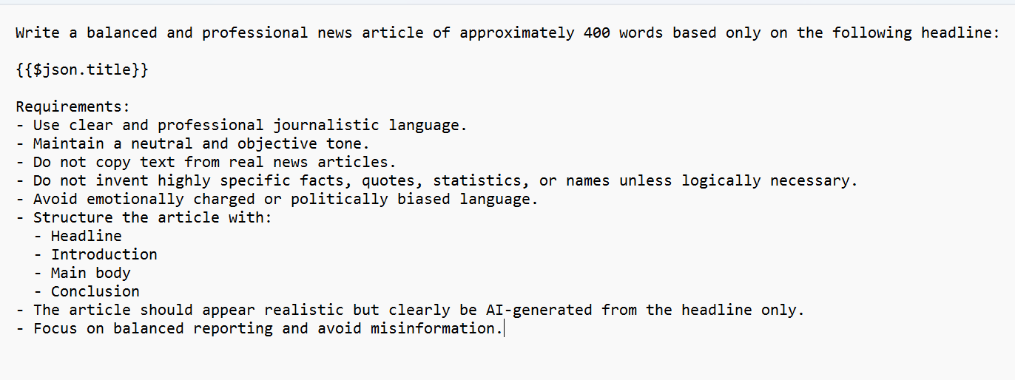Figure 1: prompt for LLM News Article Generator.

3.4 HTML Extraction and Preprocessing:
Original article content was retrieved using HTTP Request nodes within the n8n workflow and subsequently processed using Python-based HTML extraction scripts. The HTTP Request nodes accessed the original BBC and Guardian article webpages through their publicly available links collected from RSS feeds. Once the webpage content was retrieved, Python scripts were used to clean and preprocess the raw HTML data before comparative computational analysis.
The extraction process removed HTML tags, formatting noise, embedded scripts, advertisements, navigation menus, and other unnecessary webpage elements that were not directly related to the article text. This preprocessing stage was important because raw webpage content often contains additional structural information that may negatively affect sentiment analysis, semantic similarity evaluation, and comparative bias estimation.
After cleaning, the workflow extracted the main article body and converted it into a simplified textual format suitable for computational analysis. The cleaned text was then prepared for word-level, sentence-level, and document-level analytical evaluation together with cosine similarity analysis between original and AI-generated articles.
This process improved the accuracy and consistency of the computational analysis by ensuring that only relevant journalistic text was analysed. Removing unnecessary webpage content reduced noise within the dataset and improved the reliability of sentiment estimation, semantic similarity evaluation, and misinformation risk analysis performed by the Python analytical scripts.

3.5 Bias Analysis Methodology:
The project implements computational bias analysis inspired by Fang et al. (2024).
The workflow analyses:
- word-level bias.
- sentence-level sentiment variation.
- document-level framing.
- semantic similarity.
- misinformation indicators.
Python analytical scripts compare generated and original articles using:
- emotional wording.
- sentiment polarity.
- vocabulary variation.
- structural similarity.
Although computational analysis can identify measurable differences, the methodology remains limited in its ability to fully interpret political nuance, journalistic intention, or broader socio-cultural context.

3.6 Mathematical Bias and Risk Evaluation:
Word-Level Bias Estimation:
$$Bias_{word}=\frac{N_{biased terms}}{N_{total words}}$$
Where:
- $N_{biased terms}$represents emotionally charged or potentially biased words.
- $N_{total words}$represents the total number of words within the analysed article.
- The logic of the word-level bias equation is based on calculating the proportion of emotionally weighted or potentially biased vocabulary within the analysed article. The Python analytical script first counts the number of predefined emotionally charged words identified within the text and then divides this value by the total number of words contained in the article.
- A higher word-level bias score indicates increased usage of emotionally weighted or potentially suggestive language, while a lower score suggests more neutral linguistic framing. This approach provides a simplified computational method for estimating linguistic bias within original and AI-generated journalism.

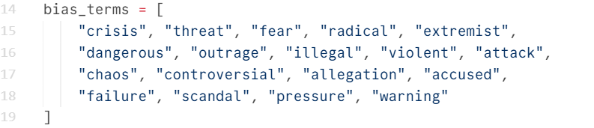
Figure2: bias terms from python Script.
Figure 2 additionally presents the predefined bias vocabulary list implemented within the Python analytical script. The bias_terms array contains emotionally weighted or potentially suggestive words such as “crisis”, “threat”, “fear”, “radical”, “extremist”, “dangerous”, “chaos”, and “scandal”. These terms were manually selected as simplified indicators of emotionally charged or potentially biased journalistic language.
During analysis, the Python script compared each word from the extracted article text against this predefined vocabulary list. If a word matched one of the terms contained within the bias_terms array, the script counted it as a potentially biased term. The total number of matched terms was then used within the word-level bias estimation equation to calculate the proportion of emotionally weighted vocabulary within the analysed article.
The purpose of the predefined bias vocabulary was not to classify articles as politically biased with complete certainty, but rather to provide a simplified computational method for identifying emotionally charged wording and comparative framing variation between original and AI-generated journalism. Higher occurrences of these predefined terms may indicate stronger emotional framing or more linguistically intense reporting within the analysed content.

Sentence-Level Sentiment Analysis:
$$Sentiment_{sentence}=\frac{\sum_{i=1}^{n}{Sentimen}t_{i}}{n}$$
Where:
- $Sentiment_{i}$ represents the sentiment score of each analysed sentence.
- $n$ represents the total number of analysed sentences.
- The logic of the sentence-level sentiment equation is based on calculating the average sentiment polarity across all sentences contained within the analysed article. The Python analytical script first estimated the sentiment score of each sentence individually by identifying positive and negative emotionally weighted vocabulary. These individual sentence sentiment values were then added together and divided by the total number of sentences within the article. A positive sentiment score indicates relatively positive or supportive language, while a negative score suggests more negative or emotionally critical wording. Values closer to zero indicate comparatively neutral journalistic tone. This approach allowed the workflow to estimate overall emotional framing and sentiment intensity within original and AI-generated journalism.

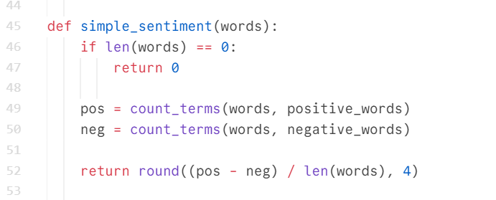
Figure 3: sentiments from python script.
Figure 3 illustrates the Python function used for sentence-level sentiment estimation within the workflow. The simple sentiment function was designed to calculate the overall emotional polarity of analysed article text by comparing positive and negative vocabulary occurrences.
The function first checks whether the analysed word list is empty. If no words are present, the function returns a sentiment value of zero to avoid mathematical division errors during analysis. The script then counts the number of positive words and negative words identified within the article using predefined vocabulary lists stored within the workflow.
The Python script subtracts the number of negative words from the number of positive words and then divides the result by the total number of words contained in the article. The final value is rounded to four decimal places to standardise comparative analysis across multiple articles.
The purpose of this calculation was to estimate the overall emotional tone and sentiment polarity within original and AI-generated journalism. Positive values indicated relatively positive or supportive language, while negative values suggested more emotionally negative or critical wording. Values close to zero indicated comparatively neutral journalistic tone. This simplified lexicon-based approach allowed the workflow to estimate sentiment variation computationally within the automated comparative analysis process.
Document-Level Bias Analysis:
$$Bias_{document}={(B}_{w}+B_{s})/2$$
Where:
- $B_{w}$represents word-level bias
- $B_{s}$represents sentence-level sentiment bias.
- The logic of this equation is based on combining two levels of computational bias analysis into one overall document-level indicator. The word-level score identifies the proportion of emotionally charged or potentially biased vocabulary within the article, while the sentence-level score reflects broader sentiment or framing variation across the text. By averaging these two values, the workflow produces a simplified document-level bias score that can be used to compare original journalism with AI-generated outputs.
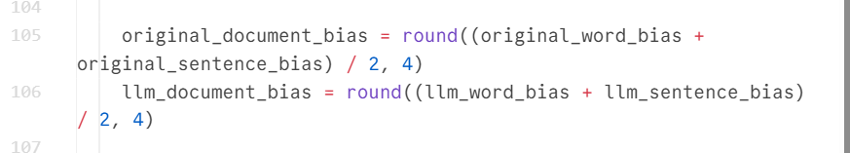
Figure 4: Document level biased from python script.
Figure 4 illustrates the Python implementation of document-level bias estimation within the workflow. The script first calculates word-level bias by identifying predefined emotionally charged vocabulary within the article text. It then calculates sentence-level bias using sentence count and bias term frequency. Finally, both values are combined and divided by two to produce a single overall document-level comparative bias indicator.
The purpose of this calculation was to provide a simplified but explainable estimation of linguistic framing across the complete article. Higher document-level bias values suggest stronger emotionally weighted wording or increased linguistic variation, while lower values suggest comparatively neutral article framing. This approach does not claim to detect political bias with certainty; rather, it provides a computational indicator for comparative analysis between original and AI-generated journalism.
.
Misinformation Risk Estimation:
$$Risk_{misinfo}=1-Similarity(Original,Generated)$$
Lower similarity values may indicate:
unsupported generated information hallucinated details framing shifts or factual inconsistencies.
Where:
- Similarity (Original, Generated) represents the semantic similarity score between the original article and the AI-generated article.
- 1 - Similarity converts similarity into misinformation risk estimation.
- The logic of the misinformation risk equation is based on estimating how closely the AI-generated article matches the original journalistic source. The workflow first calculated semantic similarity between the original and generated articles using overlap similarity analysis. This similarity score represented the degree of factual and contextual overlap between both text representations. The misinformation risk value was then calculated by subtracting the similarity score from one. As a result, higher similarity values produced lower misinformation risk scores, while lower similarity values produced higher misinformation risk scores.
The purpose of this approach was to estimate whether the generated article introduced unsupported contextual interpretation, hallucinated information, framing variation, or factual inconsistency when compared with the original journalism source. Lower similarity values may indicate that the AI-generated article diverged substantially from the original article structure or meaning, potentially increasing the risk of misinformation or unsupported generated content. However, the workflow acknowledges that semantic similarity analysis provides a computational estimation rather than definitive proof of misinformation because contextual interpretation and factual accuracy remain difficult to fully evaluate through automated comparison techniques alone.
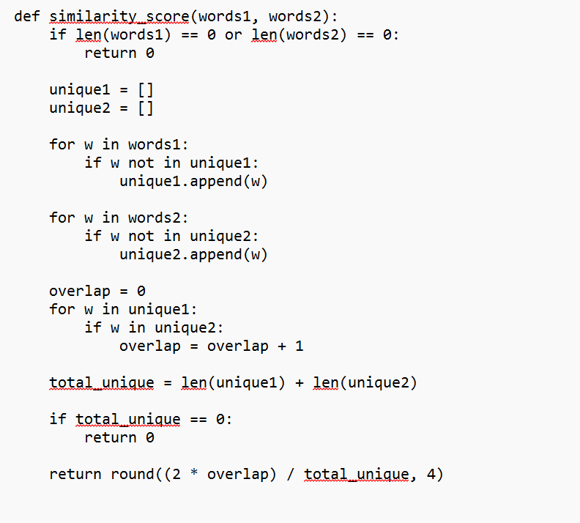
Figure 5: Misinformation Risk Code from python script.
Figure 5 illustrates the Python implementation of the similarity score function used within the workflow to estimate semantic overlap between original and AI-generated articles. The function compares vocabulary similarity between both text representations in order to estimate factual overlap and potential misinformation risk. The function first checks whether either article contains zero words. If one of the articles is empty, the function immediately returns a similarity value of zero in order to avoid invalid mathematical calculations. The script then creates two separate lists called unique1 and unique2. These lists store only unique words extracted from the original article and the AI-generated article. Duplicate words are intentionally removed so that repeated vocabulary does not artificially increase similarity scores.
Next, the workflow calculates the number of overlapping words shared between both articles. This is achieved by iterating through each unique word in the original article and checking whether the same word also exists within the generated article vocabulary list. Each matching word increases the overlap count.
The purpose of this process was to estimate how closely the AI-generated article matched the original journalistic source. Higher similarity values suggested stronger factual overlap and reduced misinformation risk, while lower similarity values indicated greater contextual variation between original and generated content. Significant variation may suggest unsupported generated information, hallucinated details, framing shifts, or factual inconsistency introduced during AI-generated rewriting. However, the workflow acknowledges that semantic similarity analysis provides a computational estimation rather than definitive proof of misinformation because contextual meaning and factual accuracy remain difficult to fully evaluate through automated comparison techniques alone.
Semantic Overlap Measurement:
Similarity = (2 × Overlap) / Total Unique Words
This calculation was used to estimate the similarity between the original news article and the AI-generated article.
Where:
- Overlap represents the number of unique words appearing in both articles.
- Total Unique Words represents the combined number of unique words identified across the original and generated articles.
A higher similarity score indicates that the generated article is more closely aligned with the original article and demonstrates greater factual overlap.
A lower similarity score indicates greater variation between the original and generated content and may suggest unsupported contextual interpretation, framing changes, or potential hallucinated information.
The similarity score ranges from:
- 0 = completely different content.
- 1 = highly similar content.
- The logic of this calculation is based on comparing shared vocabulary between the original article and the AI-generated article. Articles containing a larger number of overlapping words produce higher similarity values, while articles with fewer shared words produce lower similarity values. Within this research, the similarity score was used as a comparative indicator of factual overlap and was subsequently used to estimate potential misinformation risk. Higher similarity values suggested lower misinformation risk, whereas lower similarity values suggested greater narrative variation between the original and generated articles.

3.7 Ethical, Copyright and Responsible AI Considerations:
This project utilizes publicly available news articles obtained through BBC and Guardian RSS feeds solely for non-commercial academic research purposes. The collected material is used exclusively for analytical comparison and computational evaluation and is not redistributed, republished, or commercially reused.
Although RSS feeds provide access to publicly available article metadata and content, they do not grant permission for large-scale redistribution, republication, or storage of copyrighted journalistic material. Consequently, the workflow avoids redistributing complete articles and instead focuses on metadata extraction and comparative analytical processing.
All AI-generated outputs are clearly labelled as:
“AI-generated for research purposes.”
The project follows Responsible AI principles including:
- Transparency: refers to clearly distinguishing between original journalism and AI-generated content throughout the workflow so that users can easily understand the origin of the information being analyzed. Transparency helps prevent confusion between human-written news articles and content generated by AI systems. Within this research, transparency was maintained by keeping the original BBC and Guardian articles separate from the GPT-generated articles at every stage of the workflow. For example, the workflow first collected the original article from the RSS feed and then generated a separate AI-written article based on the same headline. Both versions were stored and analyzed independently, allowing direct comparison between the original journalism and the AI-generated output. This ensured that generated content was never presented as authentic journalism and that all analytical results could be traced back to their original source.
- Explainability: refers to providing clear and understandable analytical outputs that allow users to understand how the system produced its results. Rather than generating conclusions without justification, the workflow presents measurable indicators such as bias scores, sentiment values, similarity measurements, and misinformation risk scores generated by the Python analytical scripts. These outputs help explain why a particular article was classified as having higher or lower bias or misinformation risk. For example, if an AI-generated article receives a higher document-level bias score than the original article, the workflow provides supporting measurements from word-level and sentence-level analysis that contribute to the result. Similarly, similarity and misinformation risk scores allow users to understand the degree of overlap between the original and generated articles. This approach improves transparency and trust by making the analytical process visible and easier to interpret rather than relying on unexplained automated decisions.
- Accountability: refers to recognizing and accepting the limitations, risks, and ethical responsibilities associated with the development and use of AI-generated journalism systems. Accountability ensures that the outputs produced by the workflow are not treated as automatically accurate or free from error. Within this research, accountability was maintained by acknowledging that the implemented computational techniques provide comparative indicators rather than definitive proof of misinformation, political bias, or factual accuracy. For example, the workflow may identify a high misinformation risk score based on reduced similarity between original and generated articles; however, this does not guarantee that the generated article contains false information. The research therefore recognizes the limitations of automated analysis and emphasizes that human judgement remains important when interpreting results. Additionally, ethical responsibilities were considered through the inclusion of Responsible AI principles, copyright awareness, and the clear communication of the system's capabilities and limitations throughout the dissertation.
- Source Traceability: refers to maintaining a clear and identifiable connection between AI-generated articles and their original source articles collected from BBC and Guardian RSS feeds. Source traceability ensures that every generated article can be linked back to the original news headline and source used during content generation and analysis. Within this research, source traceability was maintained by storing the article title, source name, and article link throughout the workflow. For example, when a BBC or Guardian article was collected through an RSS feed, the original title and URL were retained and passed through the workflow together with the generated article and analytical results. This allowed the generated content, bias scores, and misinformation risk measurements to be traced back to the specific source article from which they originated. Maintaining source traceability improves transparency, supports result verification, and helps ensure that analytical findings can be reviewed and validated against the original journalism source.
The workflow was designed exclusively for controlled academic evaluation and is not intended for unrestricted public deployment without appropriate governance mechanisms, verification safeguards.
The project additionally acknowledges the limitations of computational bias and misinformation analysis techniques. Analytical outputs are therefore interpreted as experimental comparative indicators rather than definitive factual judgments.

Chapter 4 – System Design and Implementation:

4.1 Workflow Architecture:
The workflow was implemented using the n8n automation platform.
The workflow integrates:
- RSS collection.
- article formatting.
- GPT-based generation.
- HTML extraction.
- Python analytical scripts.
- Dashboard-style result generation.
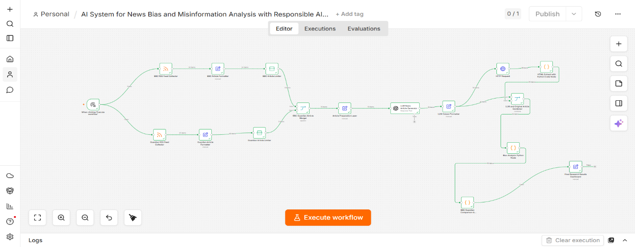
Figure 6: Overall n8n Workflow Architecture.
Explanation:
Figure 6 illustrates the complete Agentic AI workflow implemented within the n8n automation platform. The workflow integrates RSS-based news collection, GPT-based article generation, HTML extraction, Python analytical processing, and comparative misinformation evaluation.
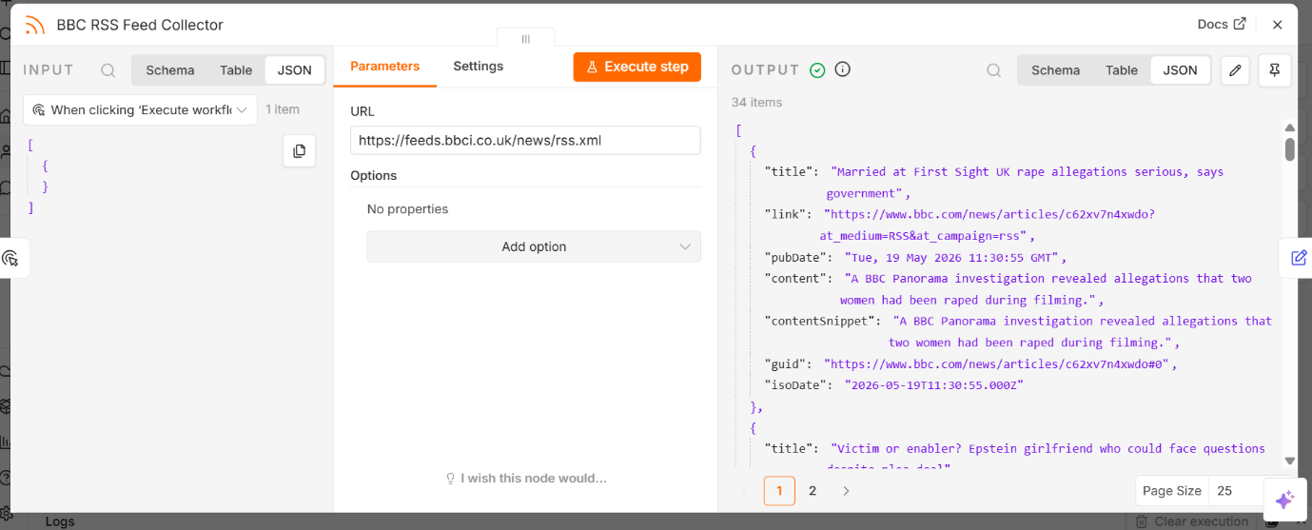
Figure 7: BBC RSS Feed Collection Layer.
Figure 7 demonstrates the RSS feed collection process responsible for retrieving article metadata, publication links, and source information from BBC RSS feeds.
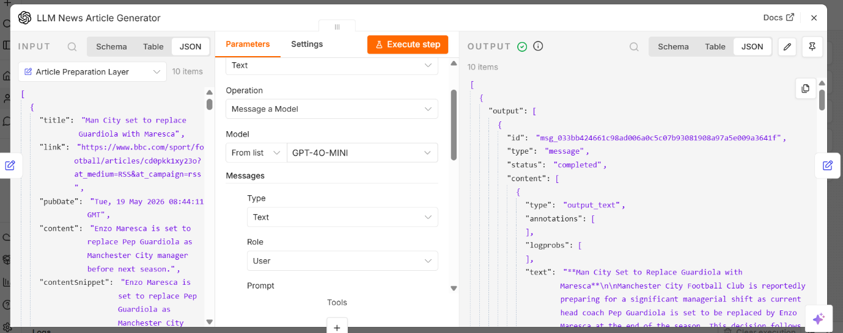
Figure 8: GPT-Based Article Generation Layer.
Figure 8 presents the GPT-based article generation component responsible for producing AI-generated news-style articles using headline-driven prompt construction.
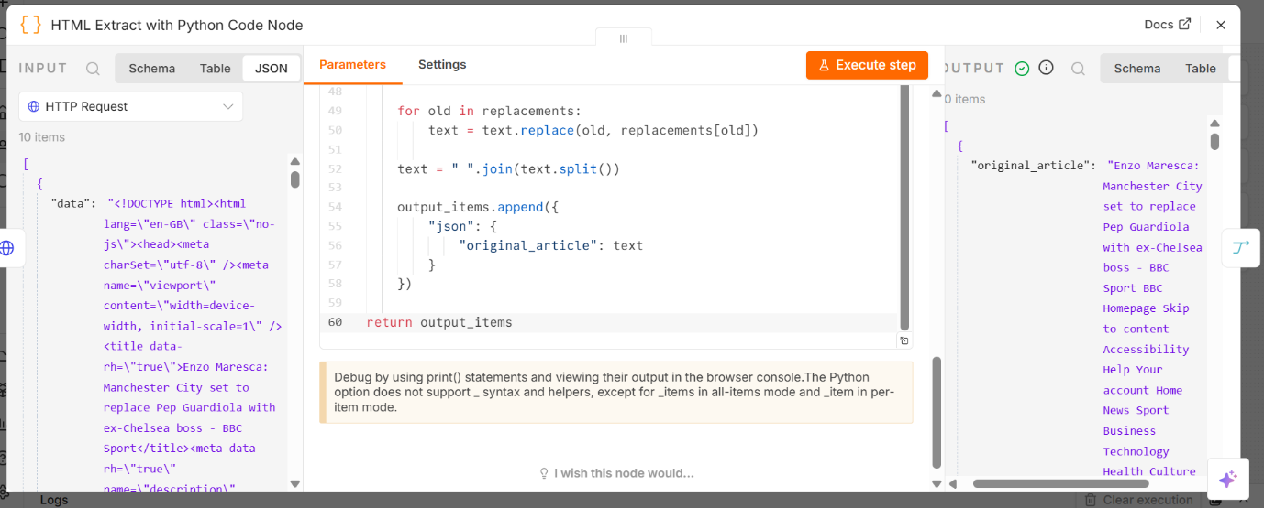
Figure 9: HTML Extraction and Processing Layer.
Figure 9 illustrates the HTML extraction process used to retrieve and clean original article content prior to computational analysis.
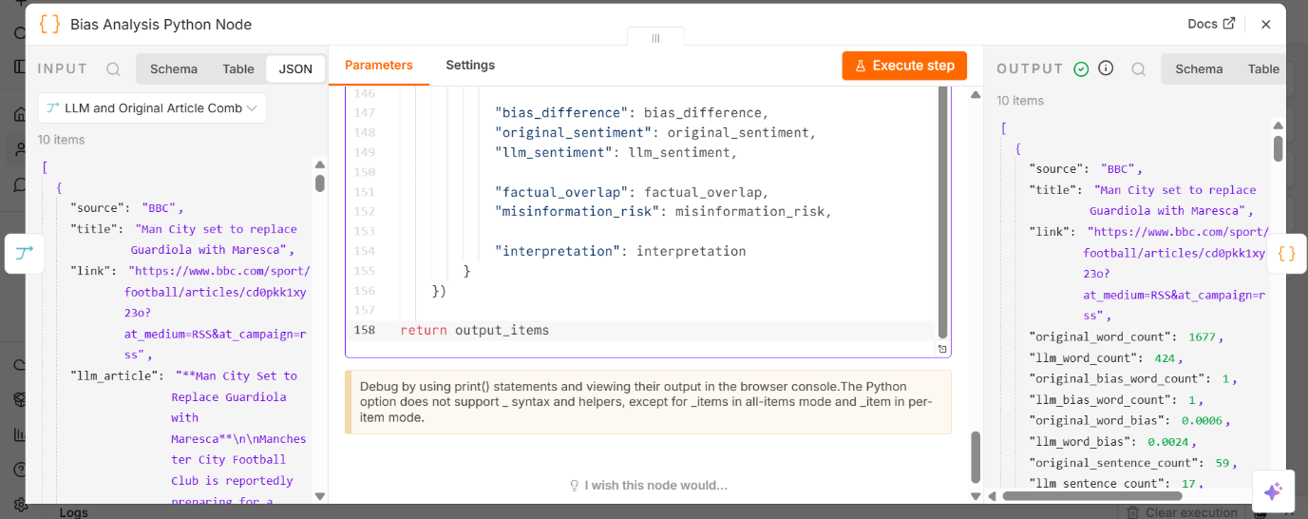
Figure 10: Bias Analysis Python Node.
Figure 10 demonstrates the Python analytical component responsible for comparative sentiment analysis, linguistic bias estimation, semantic overlap similarity measurement, and misinformation risk evaluation.
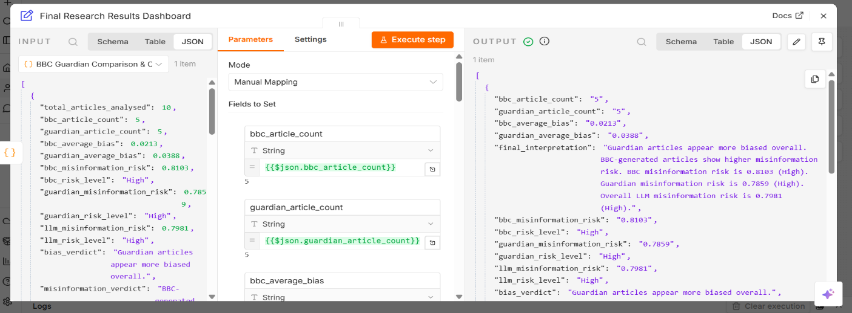
Figure 11: Final Research Results Dashboard.
Figure 11 presents the final dashboard output showing comparative bias indicators, misinformation risk estimation, and analytical summaries generated by the workflow.

Chapter 5 – Results and Evaluation:

5.1 Comparative Bias Analysis:
The workflow successfully generated measurable analytical differences between professionally written journalism and AI-generated outputs.
Table 1 presents the comparative bias scores for BBC and Guardian articles. The results indicate that BBC articles produced a slightly higher bias score (0.0374) compared with Guardian articles (0.0302), suggesting minor differences in linguistic framing and emotionally weighted language.

Table 1: Comparative Bias Analysis:
Source | Bias Score
BBC | 0.0374
Guardian | 0.0302

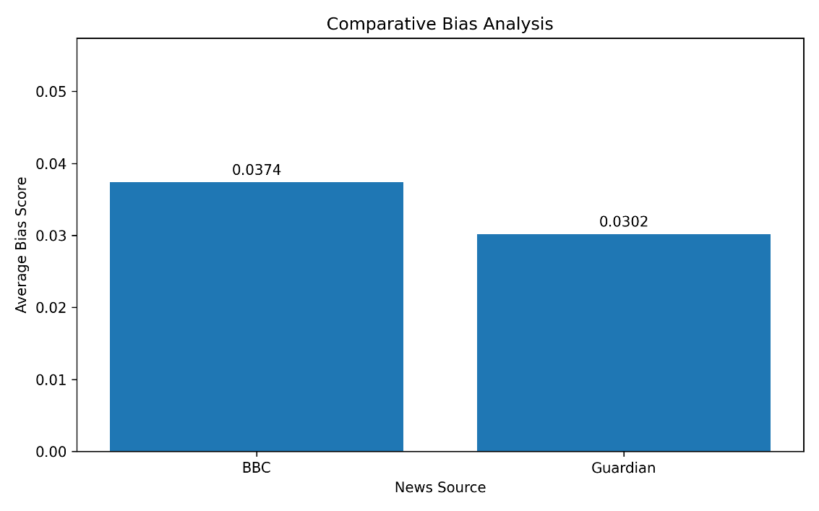
Figure 12: Comparative Bias Analysis Graph.
Figure 12 demonstrates comparative bias indicators identified between BBC-generated and Guardian-generated analytical outputs.
5.2 Misinformation Risk Evaluation:
Table 2 presents the misinformation risk evaluation results generated during comparative analysis between original and AI-generated articles. All analysed outputs were classified within the High-risk category, indicating measurable semantic variation between original journalism and AI-generated content. The findings suggest that AI-generated articles may introduce unsupported contextual interpretation, framing variation, or reduced factual overlap during automated content generation.
Table 2: Misinformation Risk Evaluation.
Source | Risk Score | Level
BBC | 0.8123 | High
Guardian | 0.7904 | High
Overall LLM Output | 0.8013 | High

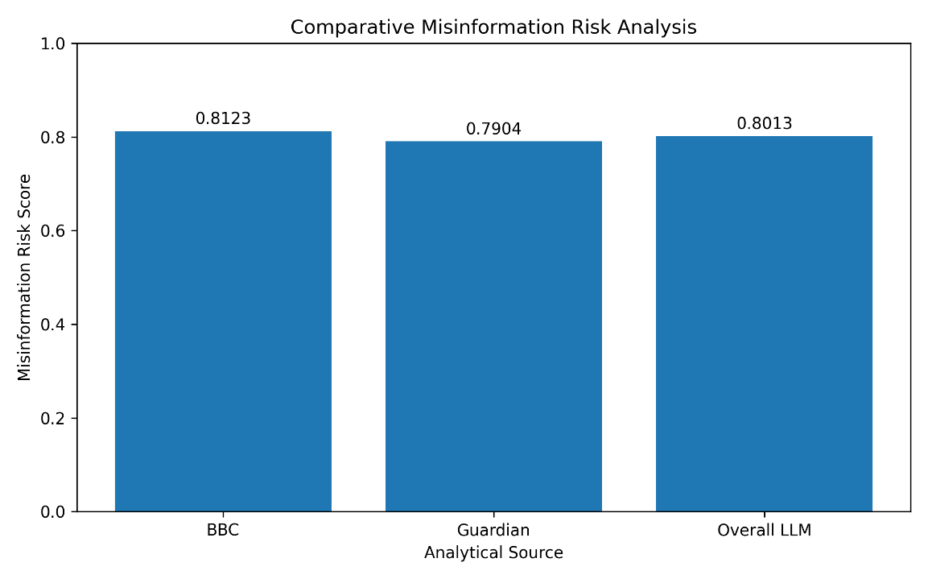
Figure 13: Comparative Misinformation Risk Graph.
Figure 13 illustrates comparative misinformation risk indicators estimated through semantic similarity and analytical evaluation techniques.

5.3 Comparative Findings:
The output generated demonstrated measurable differences in:
- wording: refers to differences in vocabulary and language usage between original and AI-generated articles.
- Emotional framing: refers to variations in emotionally weighted or suggestive language within generated journalism.
- Sentiment intensity: refers to the overall strength of positive or negative emotional tone identified during sentiment analysis.
- Semantic similarity: refers to the degree of factual and contextual overlap between original and AI-generated articles.
The findings suggest that AI-generated journalism may introduce subtle narrative and structural variation when compared with professionally written reporting.

5.4 Interpretation of Results:
The findings partially align with Fang et al. (2024), who identified measurable framing and sentiment variation within AI-generated journalism. Similar patterns were observed within this study, where AI-generated articles demonstrated noticeable differences in emotional wording, semantic similarity, and narrative structure when compared with professionally written journalism. Although the workflow successfully identified these variations through computational analysis, the results also demonstrate the limitations of relying solely on automated analytical techniques for interpreting complex journalistic meaning.
The current workflow further highlights the importance of explainable analytical outputs and Responsible AI governance within automated journalism systems. While workflow automation improves analytical efficiency and scalability, unrestricted AI-generated journalism may increase the risk of misinformation propagation, contextual distortion, and misleading narrative framing. Consequently, transparency, explainability, source traceability, and human oversight remain essential for ensuring the responsible use of AI-generated content within digital media environments.

Chapter 6 – Discussion:

6.1 Critical Discussion:
The workflow successfully automated comparative analysis between professionally written journalism and AI-generated outputs using computational linguistic and semantic evaluation techniques. The findings demonstrated that AI-generated journalism may subtly alter emotional framing, vocabulary selection, and narrative structure even when prompted to maintain a neutral journalistic tone. This partially aligns with Fang et al. (2024), who similarly identified measurable framing variation within AI-generated news outputs.
However, the findings remain dependent on probabilistic language generation behaviour and simplified heuristic analytical assumptions. Although the workflow successfully identified measurable differences in sentiment intensity and semantic similarity, computational analysis alone cannot fully interpret political nuance, contextual meaning, journalistic intention, or broader socio-cultural framing. Consequently, the analytical outputs should be interpreted as comparative computational indicators rather than definitive evidence of misinformation or political bias.
The relatively high misinformation risk values additionally suggest that semantic similarity alone may not guarantee factual reliability. In several cases, AI-generated articles preserved coherent sentence structure while introducing subtle contextual interpretation and unsupported framing variation. These findings support concerns raised by Bender et al. (2021) and Weidinger et al. (2021), who argue that large language models may generate highly convincing text despite limitations in factual grounding and contextual understanding.
Furthermore, the study highlights the importance of Responsible AI governance within automated journalism systems. While workflow automation improves scalability and analytical efficiency, unrestricted deployment without verification safeguards may increase the risk of misinformation propagation and misleading generated content. Therefore, transparency, explainability, human oversight, and continuous evaluation remain essential components for the responsible use of AI-generated journalism systems.

6.2 Responsible AI Implications:
The project demonstrates the importance of Responsible AI principles within automated journalism systems.
The workflow therefore incorporated:
- transparency mechanisms.
- explainable outputs.
- source preservation.
- governance awareness.
These safeguards align with the Responsible AI principles discussed by Stahl (2021), Yu et al. (2025), and Raza et al. (2025).

6.3 Methodological Limitations:
Several limitations were identified during the research process.
First, computational bias estimation remains dependent on heuristic assumptions and sentiment-based analytical methods. Second, the workflow does not fully verify factual correctness using external fact-checking systems. Third, the project analyses a relatively limited data set and therefore may not fully represent broader journalistic behavior across multiple media organizations.
Finally, computational techniques may not fully capture contextual political framing, sarcasm, cultural nuance, or real-world editorial intention.

Chapter 7 – Conclusion and Future Work:

7.1 Conclusion:
This project developed an agentic AI workflow capable of analyzing bias and misinformation risks within AI-generated journalism using computational analytical techniques and Responsible AI principles.
The workflow successfully integrated RSS feed collection GPT-based generation HTML extraction Python-based analytical scripts and dashboard-style comparative evaluation. The findings demonstrate that AI-generated journalism may introduce measurable linguistic variation, framing differences, and misinformation risks when compared with professionally written reporting.
The project additionally highlights the importance of transparency, accountability, explainability, and governance within automated journalism systems.

7.2 Future Work:
Future improvements may include the integration of real-time fact-checking APIs to improve verification accuracy and reduce the risk of hallucinated information within AI-generated journalism. Additional development could incorporate multilingual analysis to evaluate whether linguistic bias and misinformation patterns vary across different languages, cultural contexts, and international news environments.
The workflow may also benefit from transformer-based misinformation classifiers capable of providing more context-aware semantic interpretation compared with simplified lexicon-based analytical techniques. Furthermore, vector database integration and Retrieval-Augmented Generation (RAG) architectures could improve factual grounding by enabling the system to retrieve verified external information during content generation.
Additional enhancements may include explainable AI dashboards designed to improve transparency, interpretability, and user understanding of computational analytical outputs. Finally, future research should incorporate human evaluation studies involving journalism professionals, researchers, and media analysts to assess whether computational findings align with real-world journalistic interpretation and public perception.

References:
- Bender, E.M., Gebru, T., McMillan-Major, A. and Shmitchell, S. (2021) On the Dangers of Stochastic Parrots: Can Language Models Be Too Big? Proceedings of the 2021 ACM Conference on Fairness, Accountability, and Transparency. Available at: arXiv Research Paper
- Fang, X., Che, S., Mao, M., Zhang, H., Zhao, M. and Zhao, X. (2024) Bias of AI-generated Content: An Examination of News Produced by Large Language Models. Scientific Reports, 14. Available at: Nature Scientific Reports Paper
- Raza, S., Sapkota, R., Karkee, M. and Emmanouilidis, C. (2025) TRiSM for Agentic AI: A Review of Trust, Risk, and Security Management in LLM-based Agentic Multi-Agent Systems. arXiv. Available at: arXiv Research Paper
- Sakib, M.N., Islam, M.A., Pathak, R. and Arifin, M.M. (2024) Risks, Causes, and Mitigations of Widespread Deployments of Large Language Models (LLMs): A Survey. arXiv. Available at: arXiv Survey Paper
- Stahl, B.C. (2021) Artificial Intelligence for a Better Future: An Ecosystem Perspective on the Ethics of AI and Emerging Digital Technologies. Springer Nature. Available at: Springer Nature Book
- Weidinger, L. et al. (2021) Ethical and Social Risks of Harm from Language Models. Available at: arXiv Paper
- Yang, Y. et al. (2023) Accuracy and Political Bias of News Source Credibility Ratings by Large Language Models. Available at: arXiv Research Paper
- Yu, M., Meng, F., Zhou, X., Wang, S., Mao, J., Pan, L., Chen, T., Wang, K., Li, X., Zhang, Y., An, B. and Wen, Q. (2025) A Survey on Trustworthy LLM Agents: Threats and Countermeasures. arXiv. Available at: arXiv Survey Paper
- BBC News (2026) BBC RSS Feeds and Usage Guidance. Available at: BBC RSS Terms and Guidance
- The Guardian (2026) The Guardian RSS Feeds. Available at: The Guardian RSS Feeds

Appendices:

Appendix A – Complete n8n Workflow Screenshots:
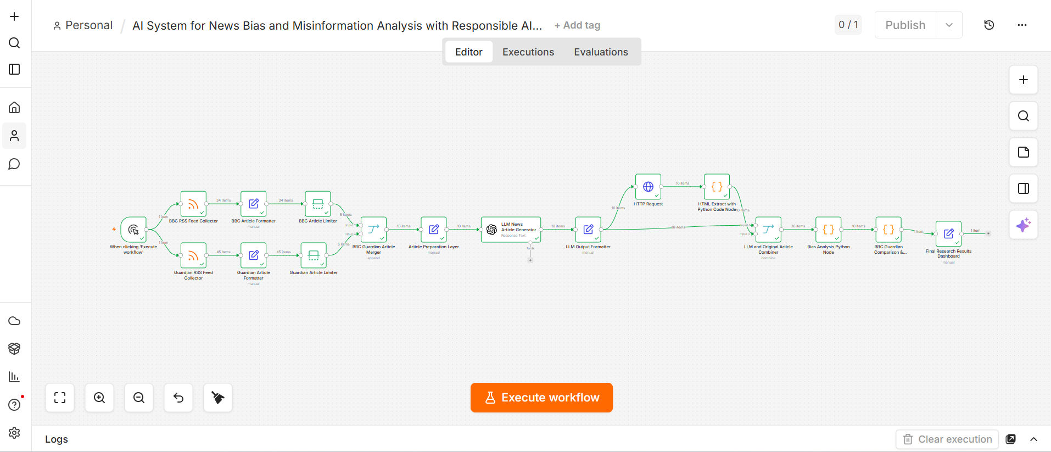
Figure 14: complete workflow of Dissertation.

Appendix B: Python Analytical Scripts:
output_items = []

positive_words = [
"good", "positive", "successful", "improve", "support",
"safe", "benefit", "progress", "strong", "stable"
]

negative_words = [
"bad", "negative", "failure", "crisis", "threat",
"dangerous", "risk", "fear", "attack", "chaos",
"pressure", "warning", "scandal", "controversial"
]

bias_terms = [
"crisis", "threat", "fear", "radical", "extremist",
"dangerous", "outrage", "illegal", "violent", "attack",
"chaos", "controversial", "allegation", "accused",
"failure", "scandal", "pressure", "warning"
]

def clean_words(text):
text = text.lower()
symbols = [".", ",", ":", ";", "!", "?", '"', "'", "(", ")", "[", "]", "{", "}", "-", "_", "/", "\\", "\n", "\t"]
for symbol in symbols:
text = text.replace(symbol, " ")
return text.split()

def split_sentences(text):
text = text.replace("?", ".").replace("!", ".")
parts = text.split(".")
sentences = []
for p in parts:
p = p.strip()
if p != "":
sentences.append(p)
return sentences

def count_terms(words, term_list):
count = 0
for word in words:
if word in term_list:
count = count + 1
return count

def simple_sentiment(words):
if len(words) == 0:
return 0

pos = count_terms(words, positive_words)
neg = count_terms(words, negative_words)

return round((pos - neg) / len(words), 4)

def similarity_score(words1, words2):
if len(words1) == 0 or len(words2) == 0:
return 0

unique1 = []
unique2 = []

for w in words1:
if w not in unique1:
unique1.append(w)

for w in words2:
if w not in unique2:
unique2.append(w)

overlap = 0
for w in unique1:
if w in unique2:
overlap = overlap + 1

total_unique = len(unique1) + len(unique2)

if total_unique == 0:
return 0

return round((2 * overlap) / total_unique, 4)

for item in _items:
data = item["json"]

source = data.get("source", "")
title = data.get("title", "")
link = data.get("link", "")
original_article = data.get("original_article", "")
llm_article = data.get("llm_article", "")

original_words = clean_words(original_article)
llm_words = clean_words(llm_article)

original_sentences = split_sentences(original_article)
llm_sentences = split_sentences(llm_article)

original_bias_count = count_terms(original_words, bias_terms)
llm_bias_count = count_terms(llm_words, bias_terms)

original_word_bias = round(original_bias_count / len(original_words), 4) if len(original_words) > 0 else 0
llm_word_bias = round(llm_bias_count / len(llm_words), 4) if len(llm_words) > 0 else 0

original_sentence_bias = round(original_bias_count / len(original_sentences), 4) if len(original_sentences) > 0 else 0
llm_sentence_bias = round(llm_bias_count / len(llm_sentences), 4) if len(llm_sentences) > 0 else 0

original_document_bias = round((original_word_bias + original_sentence_bias) / 2, 4)
llm_document_bias = round((llm_word_bias + llm_sentence_bias) / 2, 4)

bias_difference = round(llm_document_bias - original_document_bias, 4)

original_sentiment = simple_sentiment(original_words)
llm_sentiment = simple_sentiment(llm_words)

factual_overlap = similarity_score(original_words, llm_words)
misinformation_risk = round(1 - factual_overlap, 4)

if bias_difference > 0:
interpretation = "LLM article appears more biased than the original article"
elif bias_difference < 0:
interpretation = "LLM article appears less biased than the original article"
else:
interpretation = "LLM article shows similar bias level to the original article"

output_items.append({
"json": {
"source": source,
"title": title,
"link": link,

"original_word_count": len(original_words),
"llm_word_count": len(llm_words),

"original_bias_word_count": original_bias_count,
"llm_bias_word_count": llm_bias_count,

"original_word_bias": original_word_bias,
"llm_word_bias": llm_word_bias,

"original_sentence_count": len(original_sentences),
"llm_sentence_count": len(llm_sentences),

"original_sentence_bias": original_sentence_bias,
"llm_sentence_bias": llm_sentence_bias,

"original_document_bias": original_document_bias,
"llm_document_bias": llm_document_bias,

"bias_difference": bias_difference,
"original_sentiment": original_sentiment,
"llm_sentiment": llm_sentiment,

"factual_overlap": factual_overlap,
"misinformation_risk": misinformation_risk,

"interpretation": interpretation
}
})

return output_items
Appendix C – Comparative Bias Evaluation Engine script:
bbc_bias_scores = []
guardian_bias_scores = []

bbc_misinfo_scores = []
guardian_misinfo_scores = []
llm_misinfo_scores = []

for item in _items:
data = item["json"]

source = data.get("source", "")
bias = data.get("original_document_bias", 0)
misinfo = data.get("misinformation_risk", 0)

llm_misinfo_scores.append(misinfo)

if source == "BBC":
bbc_bias_scores.append(bias)
bbc_misinfo_scores.append(misinfo)

if source == "Guardian":
guardian_bias_scores.append(bias)
guardian_misinfo_scores.append(misinfo)

bbc_count = len(bbc_bias_scores)
guardian_count = len(guardian_bias_scores)
total_count = len(_items)

bbc_average_bias = sum(bbc_bias_scores) / bbc_count if bbc_count > 0 else 0
guardian_average_bias = sum(guardian_bias_scores) / guardian_count if guardian_count > 0 else 0

bbc_misinformation_risk = sum(bbc_misinfo_scores) / len(bbc_misinfo_scores) if len(bbc_misinfo_scores) > 0 else 0
guardian_misinformation_risk = sum(guardian_misinfo_scores) / len(guardian_misinfo_scores) if len(guardian_misinfo_scores) > 0 else 0
llm_misinformation_risk = sum(llm_misinfo_scores) / len(llm_misinfo_scores) if len(llm_misinfo_scores) > 0 else 0

def risk_level(score):
if score < 0.3:
return "Low"
elif score < 0.6:
return "Medium"
else:
return "High"

bbc_risk_level = risk_level(bbc_misinformation_risk)
guardian_risk_level = risk_level(guardian_misinformation_risk)
llm_risk_level = risk_level(llm_misinformation_risk)

if guardian_average_bias > bbc_average_bias:
bias_verdict = "Guardian articles appear more biased overall."
elif bbc_average_bias > guardian_average_bias:
bias_verdict = "BBC articles appear more biased overall."
else:
bias_verdict = "BBC and Guardian articles show similar bias levels."

if bbc_misinformation_risk > guardian_misinformation_risk:
misinformation_verdict = "BBC-generated articles show higher misinformation risk."
elif guardian_misinformation_risk > bbc_misinformation_risk:
misinformation_verdict = "Guardian-generated articles show higher misinformation risk."
else:
misinformation_verdict = "BBC and Guardian generated articles show similar misinformation risk."

explanation = (
"This analysis compares BBC and Guardian articles using word-level, "
"sentence-level, and document-level bias measurements. "
"It also calculates misinformation risk by comparing the LLM-generated article "
"with the original article. A higher misinformation risk means the generated "
"article has lower factual overlap with the original source and may contain "
"unsupported or hallucinated information."
)

final_interpretation = (
bias_verdict + " " +
misinformation_verdict + " " +
"BBC misinformation risk is " + str(round(bbc_misinformation_risk, 4)) +
" (" + bbc_risk_level + "). " +
"Guardian misinformation risk is " + str(round(guardian_misinformation_risk, 4)) +
" (" + guardian_risk_level + "). " +
"Overall LLM misinformation risk is " + str(round(llm_misinformation_risk, 4)) +
" (" + llm_risk_level + ")."
)

research_questions_answered = [
"Which news source shows higher average bias?",
"Which news source shows higher misinformation risk after LLM generation?",
"How much does the LLM-generated article differ from the original article?",
"Does the LLM reduce or increase biased language compared with the original source?",
"Can an automated agentic AI workflow compare bias and misinformation across BBC and Guardian articles?"
]

return [
{
"json": {
"total_articles_analysed": total_count,

"bbc_article_count": bbc_count,
"guardian_article_count": guardian_count,

"bbc_average_bias": round(bbc_average_bias, 4),
"guardian_average_bias": round(guardian_average_bias, 4),

"bbc_misinformation_risk": round(bbc_misinformation_risk, 4),
"bbc_risk_level": bbc_risk_level,

"guardian_misinformation_risk": round(guardian_misinformation_risk, 4),
"guardian_risk_level": guardian_risk_level,

"llm_misinformation_risk": round(llm_misinformation_risk, 4),
"llm_risk_level": llm_risk_level,

"bias_verdict": bias_verdict,
"misinformation_verdict": misinformation_verdict,

"explanation": explanation,
"final_interpretation": final_interpretation,

"research_questions_answered": research_questions_answered
}
}
]

Appendix D – Dashboard Outputs:

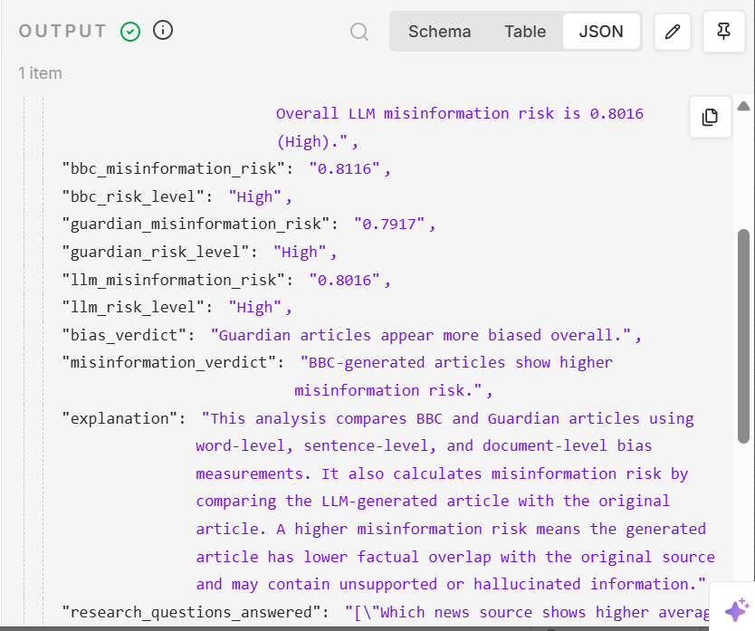
Figure 15: Output Dashboard.

Appendix E – Risk Threshold Tables

E.1 Bias Score Interpretation Thresholds
The following table 3 was used to interpret computational bias indicators generated during comparative article analysis.
Table 3: Bias Score Interpretation Thresholds.
Bias Score Range | Interpretation
0.000 – 0.020 | Low Bias
0.021 – 0.040 | Moderate Bias
0.041 – 0.060 | High Bias
Above 0.060 | Very High Bias

These thresholds were developed as simplified analytical indicators for comparative evaluation purposes within the workflow. Lower values indicate relatively neutral linguistic framing, while higher values indicate increased use of emotionally weighted or potentially biased terminology within analysed articles.
E.2 Sentiment Score Interpretation Thresholds:
The following table 4 sentiment polarity thresholds were used during sentence-level sentiment analysis.
Table 4: Sentiment Score Interpretation Thresholds.
Sentiment Score Range | Interpretation
-1.0 to -0.5 | Strong Negative Sentiment
-0.49 to -0.1 | Negative Sentiment
-0.09 to 0.09 | Neutral Sentiment
0.1 to 0.49 | Positive Sentiment
0.5 to 1.0 | Strong Positive Sentiment

Sentiment scores were calculated using lexicon-based polarity estimation techniques. Negative values represent emotionally negative wording, while positive values indicate more positive or supportive language structures.
E.3 Misinformation Risk Thresholds
The following thresholds were used to estimate misinformation risk based on semantic similarity analysis between original and AI-generated articles.

Table 5: Misinformation Risk Thresholds.
Risk Score Range | Risk Level
0.000 – 0.300 | Low Risk
0.301 – 0.600 | Moderate Risk
0.601 – 1.000 | High Risk

Misinformation risk was estimated using cosine similarity and semantic overlap analysis. Higher risk values indicate lower semantic similarity between original and generated articles, potentially suggesting hallucinated information, unsupported contextual interpretation, or narrative framing variation.
E.4 Semantic Overlap Interpretation Thresholds:
The following thresholds were used to interpret semantic overlap measurements generated during the comparison between original and AI-generated articles.

Table 6: Semantic Overlap Interpretation Thresholds.
Similarity Score | Interpretation
0.80 – 1.00 | High Semantic Similarity
0.50 – 0.79 | Moderate Semantic Similarity
Below 0.50 | Low Semantic Similarity

Higher similarity values indicate stronger overlap between the original article and the AI-generated article, suggesting that the generated content remains closely aligned with the source material. Moderate similarity values indicate noticeable variation in wording, structure, or contextual interpretation while still retaining a reasonable level of overlap with the original article. Low similarity values indicate substantial differences between the original and generated content and may suggest increased narrative variation, unsupported contextual interpretation, or potential misinformation risk. These thresholds were used as comparative indicators to support the evaluation of factual overlap between original journalism and AI-generated outputs rather than as definitive measures of factual accuracy.
Appendix F – Ethical and Copyright Notes:
F.1 Ethical and Copyright Considerations:
This project uses publicly available news articles collected through BBC and Guardian RSS feeds solely for academic research purposes. The collected material is used only for comparative analysis, computational evaluation, and workflow experimentation related to AI-generated journalism. The project does not redistribute, republish, or commercially exploit original journalistic content.
Although RSS feeds provide access to article metadata and publicly accessible links, they do not grant permission for large-scale redistribution, permanent storage, or republication of copyrighted news articles. For this reason, the workflow was designed to avoid storing or distributing complete original articles wherever possible. Instead, the project focuses on metadata extraction, limited text processing, and analytical comparison between original and AI-generated content.
All original journalistic sources are appropriately acknowledged throughout the dissertation, and the study follows fair dealing principles for research and private study under UK copyright guidance. The workflow was developed strictly for educational and analytical purposes rather than public news distribution or commercial media production.
F.2 Responsible AI Considerations:
The system generates AI-written articles using a GPT-based language model; however, these outputs are clearly identified as:
“AI-generated for research purposes.”
The generated articles are used only for internal analytical evaluation and are not presented as verified journalism or factual public reporting. The project recognises that Large Language Models may occasionally produce hallucinated information, misleading contextual interpretation, or subtle political framing despite attempts to encourage balanced content generation.
To reduce these risks, several Responsible AI measures were incorporated into the workflow, including:
- neutral prompt engineering strategies
- semantic similarity analysis.
- misinformation risk estimation.
- explainable analytical outputs.
- transparency between original and generated content.
- controlled workflow automation.
The prompt engineering process additionally instructed the language model to avoid emotionally charged language, unsupported claims, fabricated quotations, and politically biased wording where possible.
F.3 Limitations of Computational Analysis:
This study also acknowledges the limitations of computational bias and misinformation analysis techniques. Lexicon-based sentiment analysis and semantic similarity measurements cannot fully interpret:
- political nuance.
- cultural context.
- Sarcasm.
- journalistic intention.
- broader social interpretation.
Although the workflow successfully identified measurable variation in sentiment intensity, semantic similarity, and linguistic framing, these analytical outputs should be interpreted cautiously as comparative computational indicators rather than definitive proof of political bias or misinformation.
The findings partially align with previous research discussing the limitations of AI-generated journalism and automated language analysis. However, the workflow additionally demonstrates the importance of transparency, explainability, and human oversight when evaluating AI-generated news content within automated journalism systems.
F.4 Data Privacy and Human Participants:
No human participants, personal user information, or sensitive private datasets were collected during this research. All analysed material originated from publicly accessible journalistic content distributed through official RSS feed channels.

As a result, the project did not involve:
- human subject experimentation.
- personal data collection.
- medical records.
- or confidential information processing.
F.5 Research Governance Statement:
This dissertation was developed exclusively for academic research within De Montfort University. The workflow was implemented within a controlled research environment and was not designed for unrestricted public deployment without appropriate governance mechanisms, verification safeguards, and human oversight procedures.
The project therefore emphasises that automated journalism systems should be used responsibly, particularly when AI-generated content may influence public understanding, media interpretation, or information reliability.

